In the beginning, three buttons will be shown in the main menu. Pressing Start Game will take the player to the first level. Pressing How to Play will take the player to the screen where the game is explained in more detail (rules). Pressing the Exit button will immediately close the game. The images below show basically, how the screens are linked. If level 1 is cleared, than level 2 is loaded afterwards. The same goes from level 2 to level 3 always with the condition that lives are still there. The You Won screen can only be accessed when winning all three levels. It is shown when level 3 is all cleared. The user can press Play Again to begin the game from the first level or Exit to close the application.

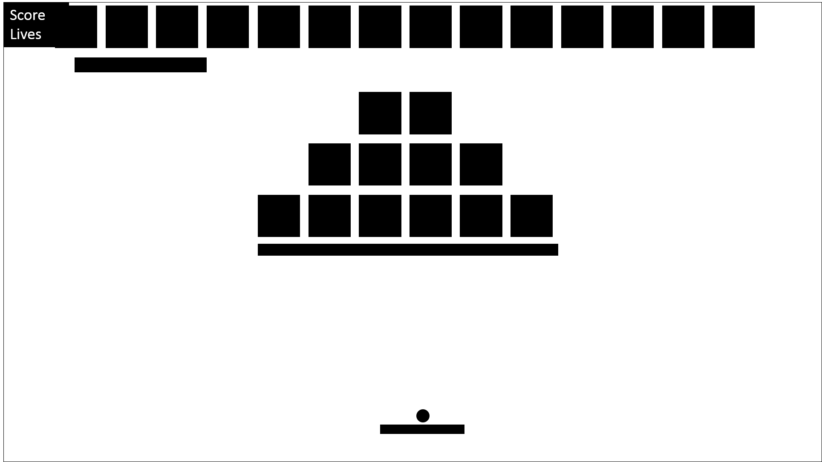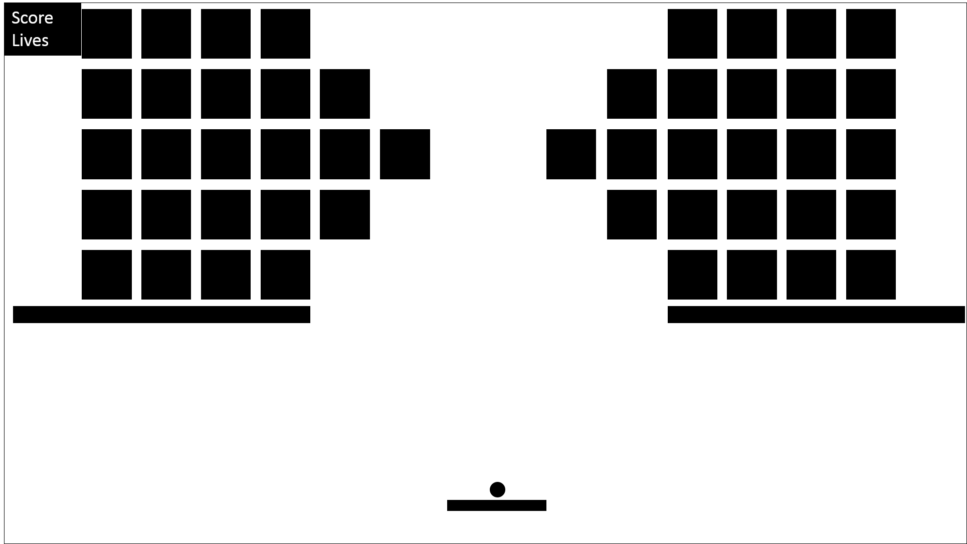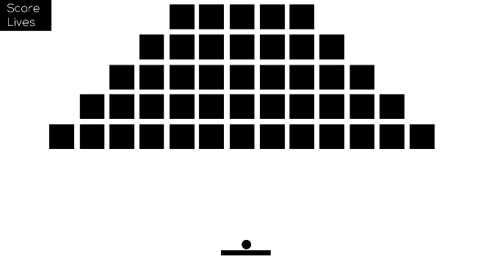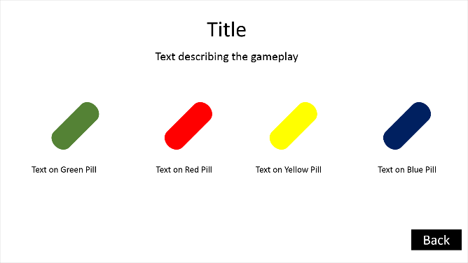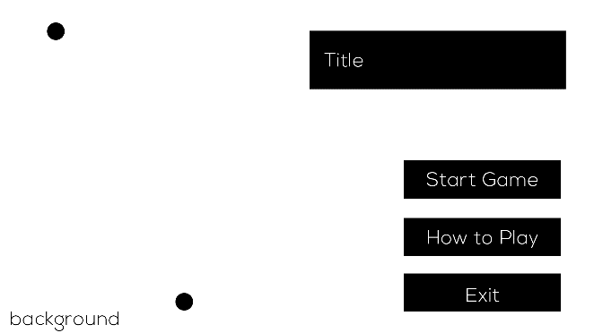

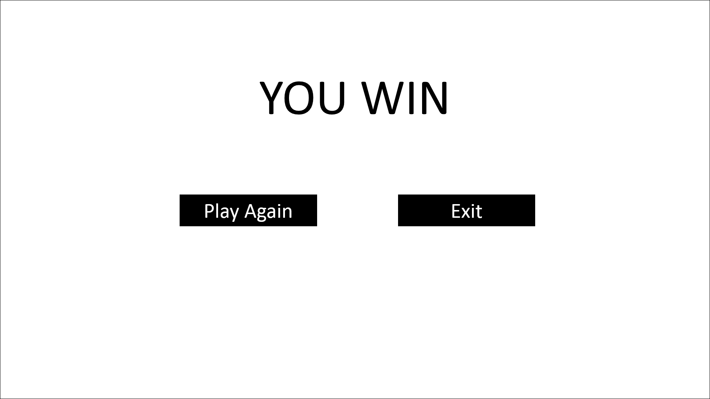

**Task 3 – P1.3** *(continued)*

If the lives are all lost in one of the levels, than the game over screen will show. In the game over screen the user can choose the play again which will take him/her to the first level or press exit to quit the game.

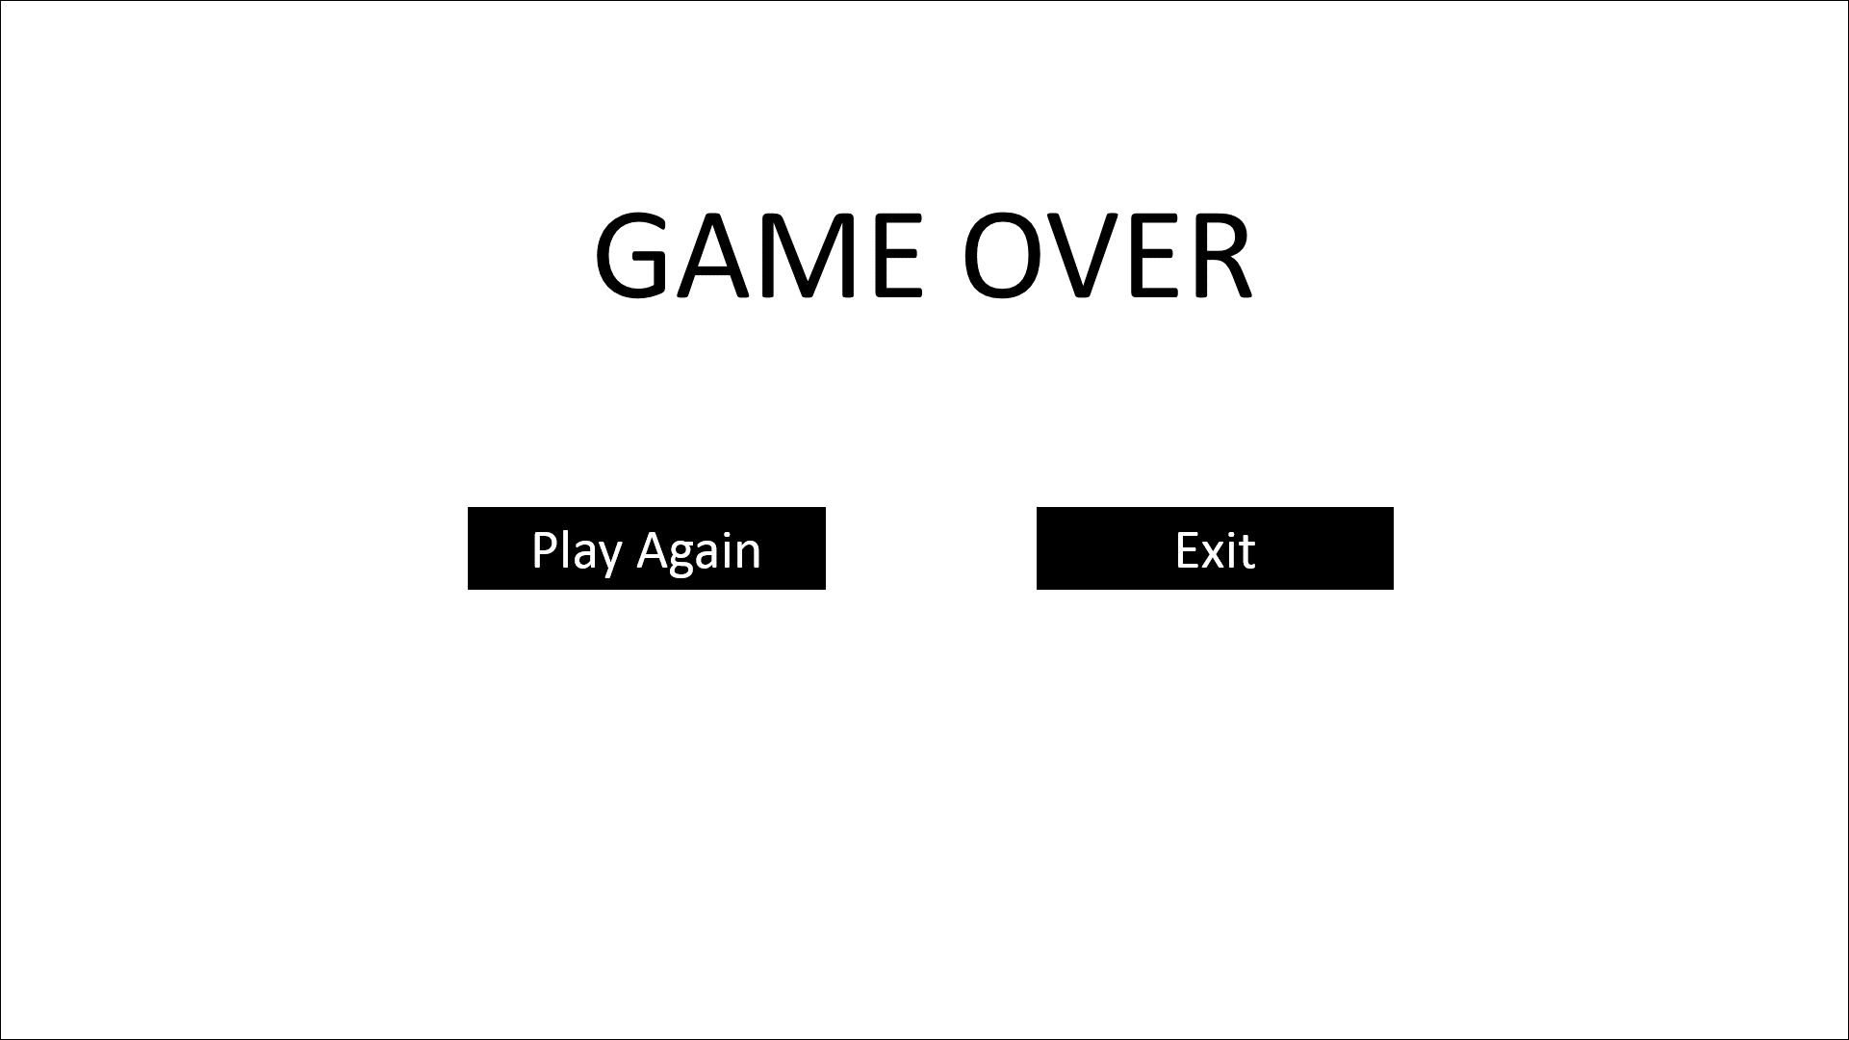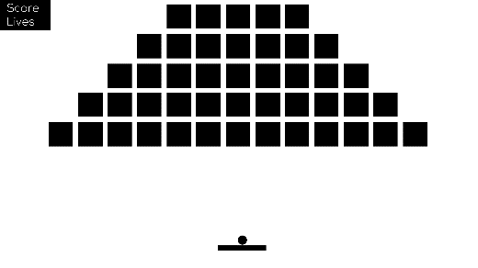

if lives = 0